**Submitted By:**

**Physics Assignment Submitted to Sir: Farhan Ahmed Jamro**

**Physics Assignment Submitted to Sir: Farhan Ahmed Jamro**

Diodes in Modern Electronics

Mr Sagar Chhabriya

[Bscs-II]

Table of Contents

* **Diode** 2
* **P-N Junction Diode** 3
* **Application of Diode** 4

**Rectifier:** 4

* **V-I characteristics of P-N junction diode** 4
* **Types of Diode** 5

**PN Junction Diode** 5

**Zener Diode** 5

**Gunn Diode** 5

**Laser Diode** 5

**Light Emitting Diode** 5

* **Operation of P-N Junction Diode** 5

**Potential Barrier:** 5

**Knee Voltage:** 5

**Reverse Leakage:** 5

**Breakdown voltage:** 5

* **Biasing Conditions for the P-N junction Diode** 6

**Zero Bias** 6

**Reverse Bias** 6

**Forward Bias** 7

# **Diode**

* An electronic component that controls the flow of current in one direction.
* Two common types of diodes.

1) Semiconductor diode (Silicon made)

2) Zener diode (Glass made)

* It is measured in mA to A. (Milli-Ampere to Ampere)
* Common usage of diode is to convert the current from AC to DC (Rectifier), it is a basic electronic component and widely used in the circuits of electronic devices, such as mobile phones, adapters, computer power supply and so forth.
* There are two terminals of diode(s)

1. 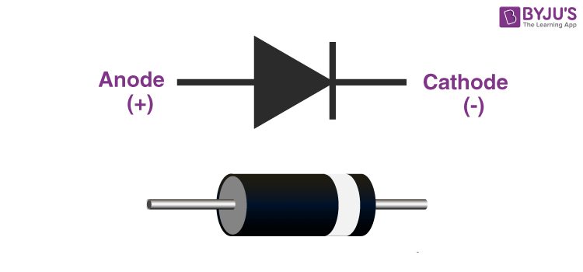Anode (+ P )
2. Cathode (- N)
3. Forward Bias
4. Reverse Bias

# **P-N Junction Diode**

When a p-type semiconductor is joined with an n-type semiconductor, the arrangement so formed is known as P-N Junction Diode.

* P-type has the majority of holes and the minority of electrons.
* N-type has the majority of electrons and the minority of holes.
* P-type and N-type are normally neutral.
* When the P-type is joined with the N-type the electron moves from the N-type to the P-type then a negative charge is created in the P-type, and holes move to the P-type due to the shorter of the electrons’ positive charge created in the N-type and this process is known as diffusion. In this way, diffusion of electrons and holes from the N-side and P-side starts this diffusion and take place till a layer is formed which is called the depletion layer. When the depletion layer is formed, the new electron can’t move to P-type because the electrons present in the depletion layer can repel the electrons which move from N-type to P-type same as for holes.
* Crossing the electron from N-type to P-type and holes from P-type to N-type we require a definite potential. Which is equal to or greater than the potential barrier then the electron and holes move easily without repealing of electron and holes present in the depletion layer.

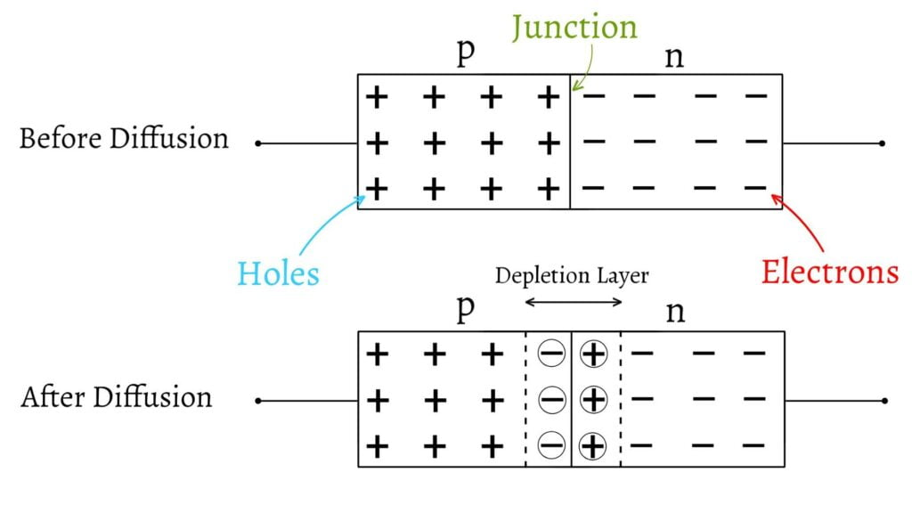

# 

# **Application of Diode**

## **Rectifier:**

Rectifier is a circuit (i.e., device) that is used to convert the AC signal (current/volt) into DC signal (current/volt).

* A P-N junction diode is used as rectifier in two ways.

1. Half wave rectifier: Output is not the continuous wave

In half wave rectifier there commonly used only one diode.

Forward Biasing: Resistance of the P-N junction becomes low.

Reverse Biasing: Resistance of the P-N junction becomes high.

1. **Full wave Rectifier: Output is in the piecewise connected waves**

**In full wave rectifier there commonly two diodes are used.**

* Conversion of the signals is achieved by using one or more diodes to block the negative half of the AC cycle, allowing only the positive half to pass through.

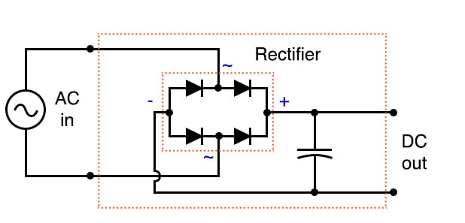

# **V-I characteristics of P-N junction diode**

A diode's V-I (voltage-current) characteristics are a graph showing the relationship between the voltage across the diode and the current through it.

**Case 1:** when the applied volt is positive and has V-I characteristics we will get the vertical line.

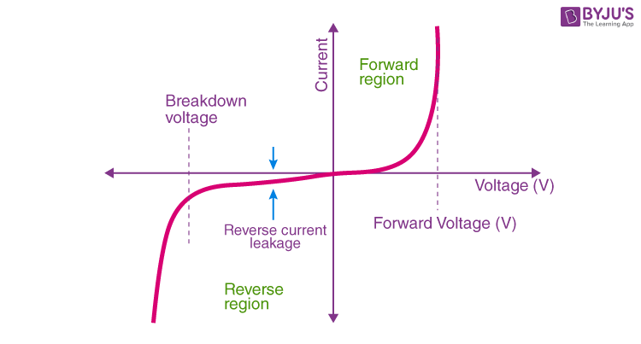**Case 2:** When the applied volt is negative and for that case, we will get the horizontal line in the negative x direction.

# **Types of Diode**

## **PN Junction Diode**

The normal type of diode.

Used in RF (radio frequency) or other low-current applications.

## **Zener Diode**

Used to provide a stable reference voltage.

Worked under reverse bias conditions and found that when a particular voltage is reached it breaks down.

Used to offer a reference voltage in power supplies.

## **Gunn Diode**

Used for producing microwave oven signals.

A semiconductor device that has two terminals.

## **Laser Diode**

Used in many applications like DVDs, CD drives, and laser light pointers.

## **Light Emitting Diode**

In forwarding bias, then the current flows through the junction and generates the light.

# **Operation of P-N Junction Diode**

## **Potential Barrier:**

The significance of this built-in potential across the junction is that it opposes both the flow of holes and electrons across the junction, which is why it is called a potential barrier. The resulting electronic device that has been made is commonly called a PN junction diode or simply a signal diode.

## **Knee Voltage:**

It is the forward voltage at which the current through the junction starts to increase rapidly.

It may be added here that to get useful current through a p-n junction, the applied voltage must be more than the knee voltage.

**Reverse Leakage:** (current in reverse biasing)

Reverse leakage in a PN junction diode refers to the small current that flows through the diode in the reverse bias direction when a reverse voltage is applied across the diode. In an ideal diode, no current should flow in the reverse bias direction, but in reality, there is always some amount of reverse leakage current.

## **Breakdown voltage:**

The breakdown voltage in a PN junction diode is the voltage at which the diode starts conducting in the reverse-biased direction, beyond a certain level of reverse voltage. When the reverse voltage applied to a diode exceeds its breakdown voltage, the diode breaks down, and a large number of current starts flowing through it.

# **Biasing Conditions for the P-N junction Diode**

## **Zero Bias**

The diode is not connected to any external voltage source. The P-type material of the diode is connected to the negative terminal of a voltmeter, and the N-type material is connected to the positive terminal of the voltmeter. In this condition there is not any flow of the current through the diode.

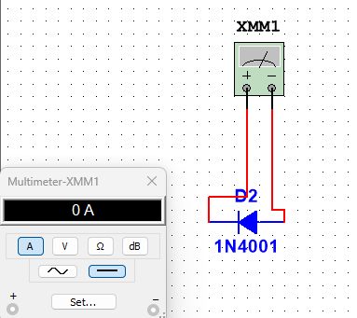

## **Reverse Bias**

The positive terminal of a voltage source is connected to the N-type terminal of the diode, and the negative terminal of the voltage source is connected to the P-type material.

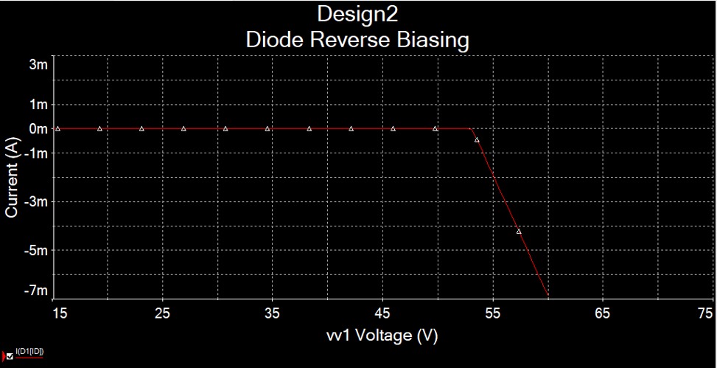

## **Forward Bias**

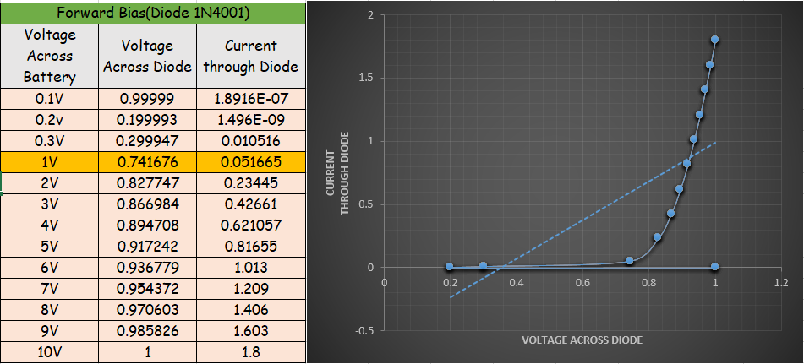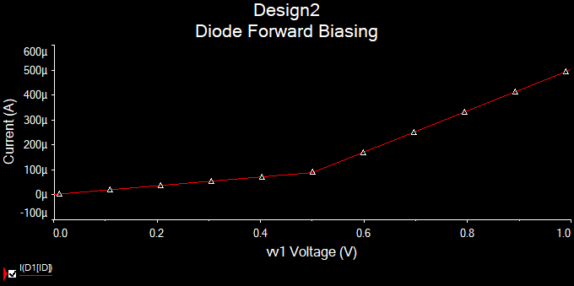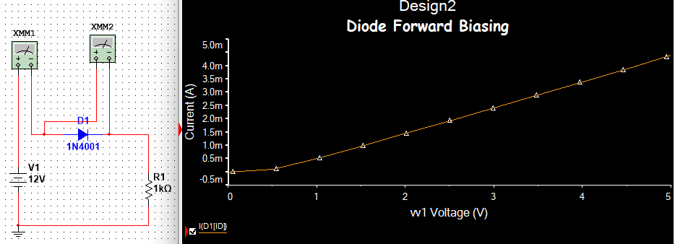The positive terminal of a voltage source is connected to the P-type material of the diode, and the negative terminal of the voltage source is connected to the N-type material.